

Intelligent Decisions for eBusiness

Intelligent Decisions for eBusiness

Intelligent Decisions for eBusiness

Intelligent Decisions for eBusiness

Intelligent Decisions for eBusiness

Intelligent Decisions for eBusiness

Intelligent Decisions for eBusiness

Intelligent Decisions for eBusiness

Intelligent Decisions for eBusiness

Intelligent Decisions for eBusiness

Georgia Tech Senior Design
Project Proposal
submitted 08/27/01
Project Proposal

TABLE OF CONTENTS

Manugistics Overview 3
Manugistics Solutions 3
NetWORKS™ 3
bstreamz™ 4
Project Overview 5
Project Resources 6
Required Skills 7

Manugistics Overview

Manugistics Group, Inc. is a leading provider of eBusiness solutions that enable intelligent decisions across trading networks. Powered by the NetWORKS™ family of products, Manugistics' solutions ensure real-time decision-making at eSpeed, so that network trading partners are empowered to make the right decisions for profitable growth.

For more than 20 years, Manugistics has been delivering reliable, quick to implement solutions that help companies make intelligent decisions. These solutions are tailored for each customer to best translate strategy to action.

Manugistics' success is echoed by more than 1100 strategic client partners including industry leaders such as Amazon.com, 3Com, Brown & Williamson, Coca-Cola Bottling, Cisco Systems, Commerx, Compaq, DuPont, General Electric, Harley-Davidson, Hormel, Nestle, Texas Instruments, and Timberland.

Manugistics has a rich history – and a limitless future. We've evolved as a company because our customers' needs have changed. And because today's business world is a radically new forum: web-driven, faster than ever, highly sophisticated.

The new Manugistics embodies the best of our heritage and introduces the absolute acceleration, velocity, and momentum that have the power to enable today's clients to realize previously unparalleled efficiencies, greater profits, and a competitive advantage – in short, extraordinary outcomes.

Manugistics Solutions

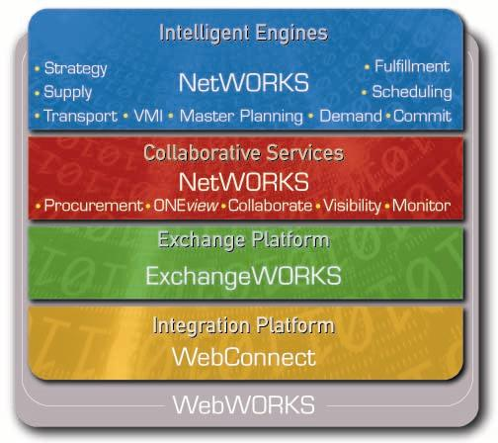
NetWORKS™

To rapidly drive results, best practice eBusiness processes must be enabled with intelligent decision making. NetWORKS products help bring a company the benefits of our Enterprise Profit Optimization, Pricing and Revenue Optimization, Supply Chain Management, and Marketplace solutions. They deliver a fully open solution that is compatible and easy to integrate with current applications, including enterprise resource planning (ERP) systems, transaction systems, execution systems, legacy systems, warehouse management systems, and point-of-sale data.

bstreamz™

Manugistics' eBusiness solution, bstreamz, enables synchronized intelligence, transforming supply chains and Internet exchanges into Intelligent Trading Networks.

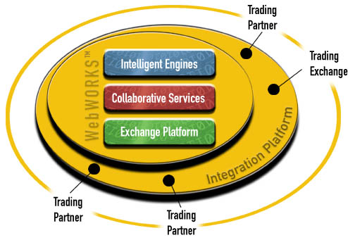
Manugistics bstreamz solutions create an environment for intelligent decision-making for our clients' market-specific trading networks. Manugistics adds intelligence to today's e-commerce transactions by providing global visibility and optimizing critical business processes such as forecast sharing, procurement, order commitments, trading partner analytics, and automated exception management. By leveraging Manugistics' bstreamz solutions, which include intelligent engines, architecture, knowledge base, and services, companies in every industry are creating intelligent trading networks to achieve profitable growth.

Project Overview

Manugistics is soliciting a Georgia Tech Senior Design team to engage on a project for the 2001-2002 school year. The focus of the project will focus on one of the intelligent engines, NetWORKS™ Demand, that Manugistics offers within its suite of solutions. This particular solution is used across our client based to support demand planning and forecasting business functions. Increasingly, companies are finding it critical to improve their forecast accuracy to remain competitive. Getting the right product to the right customer at the right time hinges on having an accurate forecast. To this end, Manugistics requests the support of a Senior Design team to participate on a project that analyzes forecast accuracy through several different perspectives.

The objective of the project is to help substantiate the value associated with an improved forecast (e.g., inventory reductions, revenue lift). The project should help to answer several key questions listed below:

- How does improved forecast accuracy impact inventory across different industries?
Currently several analyst firms provide varying metrics such as a 10% improvement in forecast accuracy equals 5% reduction in inventory, but there is not a clear understanding of how this was empirically derived nor if this varies across industry.
- How does improved forecast accuracy impact revenues across different industries?
Typically improvements in forecast will help in-stock positions so that the when the customer goes to the store to purchase the product its there on the shelf to be bought. There’s a need to substantiate the magnitude of this impact and see how it varies across various industries.
- How does forecast accuracy impact/interact with a profit and revenue management solution?
As more and more companies are looking to optimization engines that help develop pricing strategies, a clearer understanding of how forecast accuracy impacts the effectiveness of these pricing strategies needs to be achieved.
- Why should a retailer want to analyze its upstream suppliers’ forecasts?
The rationale currently is that suppliers upstream have higher aggregate of demand information which could provide insight into more macro consumer trends. This sharing of demand forecast information helps to eliminate the “bull whip” effect of inventory built up in the supply chain. An empirical study could be completed to help prove/disprove this hypothesis.

The questions above are not necessarily exhaustive but provide a glimpse of some of the business questions raised around improved forecast accuracy- questions that need carefully thought out answers. The project will be designed to provide a balance of quantitative analysis along with business and strategy formulation focused on several key industries including electronics and high tech, net markets, and retail. With Manugistics guidance, the expectation is that the project team will define appropriate project scope and work plans as well as define key deliverables throughout the project.

Project Resources

The project team will be provided all necessary resources that will make this project successful which could include but not limited to:
- Resources that provide information on Manugistics solutions that are relevant to the project
- Industry reports/presentations that help provide business context around industry specific issues
- Historical Forecast data/Actual sales data
- Information regarding various forecast algorithms
- Presentation templates

Manugistics will also provide leadership and guidance from the following individuals:

Project Role | Person | Title
Executive Sponsor | John White | Vice President  Strategic Consulting Services
Executive Manager | Ben Pivar | Director  Strategic Consulting Services
Content Expert | Lisa Leveson | Product Manager  NetWORKS Demand
Primary Contact | Mary Nishimuta Ching | Associate Consultant  Strategic Consulting Services

Required Skills
The project is suitable for teams who demonstrate the following skill sets and interests:

- Strong quantitative skills
- Good working knowledge of Microsoft Office Suite (particularly Excel and Access)
- Good written and verbal communication ability
- Ability to work effectively on a team and support high levels of performance
- Developing ability to conduct structured problem solving.
- High level understanding of financial analysis
- Developing research and knowledge management skills
- Interest in supply chain strategy
- Interest in ebusiness strategy
- Interest in consultative approach in engagement

If the proposed project sounds of interest for the 2001-2002 school year, please contact the following individual to learn more or to get any questions answered. Manugistics’ Strategic Consulting Services looks forward to hearing from students who are interested in engaging in leading edge supply chain strategy.
Mary Nishimuta Ching
Ph# 678-556-5363

Email: mnching@manu.com

